**Word Walls in the Secondary Classroom**

**Best Practice Idea**

**Definition: A word wall is a display area in the classroom devoted strictly to high-frequency vocabulary that will be used or is being used during the course of a particular unit of study.**

**Background Information:**

A word wall is most likely unfamiliar to most high school teachers or is something that may have been encountered in an elementary classroom. As part of a balanced literacy approach, word walls are being used in elementary classrooms as a means of promoting vocabulary growth leading ultimately to improvement in literacy. There are many reasons, based in research, for the study of vocabulary as an explicit daily activity. From building prior knowledge to providing contextualized information to simply providing students with high-frequency words that will be encountered in particular units of study, no matter what the justification or rationale, no matter what the grade level and no matter what the subject area, word walls are and extremely effective learning and teaching tools.

**Pertinent Points About Word Walls:**

1. Words selected must be useful to students, usable by students and frequently used in the subject area.
2. Select high-frequency words that are used in the context in which you expect the students to know them.
3. Use the same display area throughout the semester for your word wall. Students, once used to the concept, will look for the wall. Consistency is important when presenting organizational ideas to a class. Refer to the display area as the ‘word wall’ as some students will remember this from their elementary experience.
4. Do not overcrowd the word wall. You may want to remove words as the unit progresses or you may want to display words by unit and then remove the entire word wall when a new unit begins. Some high-frequency words may stay up during the entire course.
5. Creatively display and organize words. It seems that in secondary schools the creative displays are left to the art department. High school students like visual stimuli as much as their elementary counterparts. Creative displays that incorporate the message behind the words can be fun (time consuming, but fun).
6. Add words in manageable amounts (usually between 5 to 7 new words at a time…per week).
7. Make word wall activities a regular and predictable part of the classroom routine. Word wall activities make for natural class openers or closers. The word wall activity should be only about 5 minutes in length unless incorporated with a larger activity.
8. Use a variety of instructional activities to review words.

** I have a large bank of activities that I draw upon for the word wall. I will provide you with an example of a(n):

* Beginning of the unit activity;
* Mid unit word wall activity;
* End of unit word wall activity

Beginning of Unit Word Wall Activity

**Description of Activity:**

Students are organized in groups of three. 5-7 new words will have been placed on the word wall. Students will be provided with the K-W-L handout as they walk into class. They are to immediately, with their groups, complete the handout using each word for the handout. I use this time to complete my administrative business (attendance, having students sign their absence forms, collecting assignments and ticking off the complete list or having students who have not completed the work sign the incomplete register, and etc.). After approximately 5 minutes I call the class back together to discuss the words, specifically what they know already, what they want to know and what they have learned that relates to each of the words given. This serves as a great springboard into discussion around the topic that will be the focus of the daily lesson.

**Example K-W-L handout:**

|  |  |  |  |
| --- | --- | --- | --- |
| **Word** | **What I Know** | **What I Want to Know** | **What I’ve Learned** |
|  |  |  |  |
|  |  |  |  |

**Students are generally familiar with the K-W-L format as it is practiced at the elementary level as part of the active reading program.**

Mid-unit Word Wall Activity:

Description of Activity:

Students will work with a partner to complete a word cluster activity. This is designed to have students reflect on what they have learned thus far in the unit. Students place one of the words from the word wall in the center of the cluster hand out and place connecting ideas or words that they have learned in the unit in the surrounding boxes. After the students have completed their handouts, I will select five partner pairs to present briefly the ideas that they have connected with the word from the word wall.



**This is a useful activity as well for having the students explore content area like main idea and supporting facts in any reading assignment that they might do.

End of Unit Word Wall Activity

**Description of Activity:**

As students near the end of the unit they will have seen the most pertinent vocabulary associated with the particular area of study. They will have learned the definitions. They will have developed contextual understanding of the words. They will have used the words within the various contexts and will be comfortable with them. The compare and contrast web brings the word wall for the unit to an appropriate closure and can also be used as a quick summative evaluation of the understanding acquired with respect to terminology presented in the unit. The teacher chooses the two words from the unit that will be presented in the web. Students will individually complete the compare and contrast web. Student will have to reach back into what they have learned in the unit to determine how the two terms coincide and how they are different or unique.



<http://www.markville.ss.yrdsb.edu.on.ca/mm/oise2005/bestpractice/wordwall.htm>

**Vocabulary Self-Assessment**

Allowing students to use descriptions composed of everyday language is important in effective vocabulary comprehension and retention.  One way to do this is through a vocabulary self-awareness chart.  Teachers then can revisit this chart throughout the unit of study, creating multiple opportunities for students to monitor their learning of the vocabulary.

Here are the steps to completing this chart:

*Student Directions:*

1. *Examine the list of words you have written in the first column*
2. *Put a “+” next to each word you know well, and give an accurate example and definition of the word.  Your definition and example must relate to the unit of study.*
3. *Place a “check” next to any words for which you can write only a definition or an example, but not both.*
4. *Place a “?“ next to words that are new to you.*

*You will use this chart throughout the unit.  By the end of the unit should have the entire chart completed.  Because you will be revising this chart, write in pencil.*

Name: Class:

|  |  |  |  |  |  |
| --- | --- | --- | --- | --- | --- |
| WORD | + | √ | ? | EXAMPLE | DEFINITION |
|  |  |  |  |  |  |
|  |  |  |  |  |  |

http://roadtoteaching.com

**P.O.S.E**

 In this activity, students come up with four clues that relate to their words.  The clues may be from one of four categories:  People, Objects, Settings, or Events.

For instance, for the word discern, students used people clues–search and rescue workers, gasoline repairman, detectives, and scientists.

1. Students read their clues one at a time.
2. Students on another team try to guess the word.

The clue-giving team earns points if their clues enable the other team to guess the word.  The word-guessing team earns points based on how quickly they can guess the word–4 points if they can guess with only one clue…1 point if they can guess after all four clues.

**Vocabulary War**

1) Teacher has a list of the key vocabulary words posted in the room (word wall).

2) Teacher explains the instructions and rules.  Instructions are each student is required to make 2-3 paper airplanes, and then write the definition of their vocabulary word on each airplane.  The class will be divided into 2-4 groups.

3) The aim of the game is to knock out members from other groups by flying their airplane over to that group.  The students that receives the airplane, reads the definition out loud, then answers it.  If the student doesn’t answer it correctly, then the person that flew the plan needs to give the correct answer.  The student that is knocked out has one last chance to fly one of his/her airplanes to another group.

4)  If a student flies their airplane and it comes back to the original group, this is called friendly-fire.  Someone, at the teacher’s choosing, has to answer that question.  If their answer is incorrect, then they are knocked out.

5)  Teacher is ultimate decision-maker.  Students can not argue with the teacher, or they will lose a chance to go.

This is a fun, silly activity, but highly effective in engaging even the hardest to reach students in thinking about vocabulary.

**Cartoon Vocabulary**

1. Discuss the word in context with the entire class
2. Students make four squares out of their paper
3. Write the definition of the word in a square and draw a picture that represents the meaning of the word.
4. Pair and share with another student. Each student says the definition of the word in their own words and explains to their partner why they drew the picture to represent the word.
5. Repeat the process with other words.

**Frayer Model**

1. In the middle of the graphic organizer, in the circle, students enter their vocabulary word,  Then, students write the definition of their vocabulary word in the upper left hand box.
2. In the upper right hand corner box, students write characteristics that come to mind about this word.
3. Students use the vocabulary word in a sentence in the lower left hand box titled Example.
4. Finally, students complete the last box, titled Non-Example.  Students draw their representation of the vocabulary word.

This graphic organizer is beneficial because it makes the students think about the vocabulary word in different ways, allowing the teacher to meet also the diverse learning styles in the classroom.

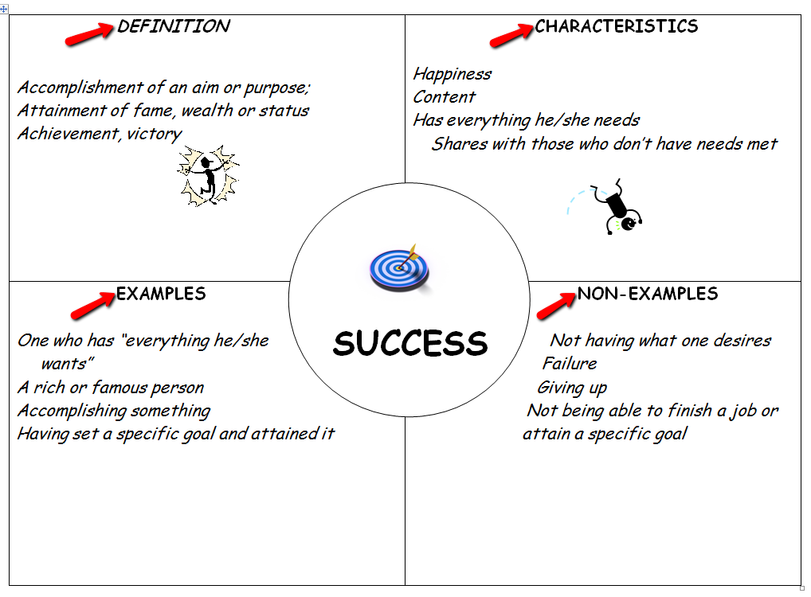

**Vocabulary Notebooks/Journals**

Individual vocabulary notebooks invite students to strengthen their word knowledge and internalize meaning for use throughout their lives. Robert J. Marzano, in his book *Building Academic Vocabulary: Teacher’s Manual ,*suggests using tabs in the booklets to note different subjects or topics. Having a dictionary definition is insufficient according to Marzano. He explains that dictionary definitions are not written in conversational language. As a result, students are unable to internalize meaning.

Dictionary definitions may be more helpful after a basic understanding of the word’s meaning is established. Marzano recommends that words be defined using “student friendly” language. He suggests including a nonlinguistic representation of the word or its meaning whenever possible.

**Steps:**

**1.** Direct students to identify unknown words, confusing words, or interesting words while they read and discuss a unit or topic. As students identify words, they write them in their vocabulary notebook.

**2.** Require students to list the exact sentence in which the word appears in the text.

**3.** After students have written the text definition, ask them to create definitions using their own words (not a dictionary definition).

**Adaptations:**

• Consider assigning students to include a list of antonyms or synonyms.

• Assign students to include a picture, drawing, or symbol, if appropriate.

• *Words in the News:* Assign students to make a list of vocabulary words from a newspaper,

magazine, or other current event resource. Then students choose one or more of the words that are of interest to them to include in their journal and why they chose it.

• Refer to *On Target: Strategies to Guide Student Learning,* During Reading: Concept

Definition Map, Pages 14-15.

• *Word Dictionary*: To help students develop a deeper understanding of a topic or unit, assign them to make a list of words that may relate to the broad topic or unit. The students place the words in alphabetical order and then define the words. A picture or guide words may also be included.

**Vocabulary Notebooks**

|  |  |  |  |
| --- | --- | --- | --- |
| Word & Page Number:  *Labyrinth pg. 11* | | Resource:  *Name of Text* | |
| Sentence in which the word was used in the text:  *Behind the castle was a labyrinth of hedges in which to hide from suspicious eyes*. | | | |
| Student Friendly Definition:  *A maze – like a group of bushes that are grouped in a maze design* | | | |
| Antonyms | Synonyms  *maze* | | Picture/drawing/symbol |